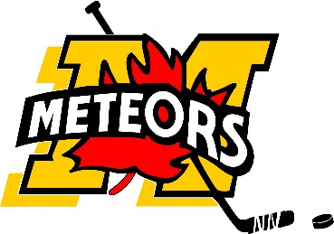
www.mitchellminorhockey.com
64th Annual

Mitchell Minor Hockey

Pee Wee Tournament
November 8th, 9th and 10th 2019
Dear Manager/Coach:

This letter serves as an invitation to our 64th Annual Pee Wee Hockey Tournament to be held on November 8, 9, 10 in Mitchell, Ontario. The tournament will start Friday am with rep & ae teams, Local League teams will start playing their 1st game later on Friday. Games will be played in both Mitchell and Monkton arenas.

The tournament format consists of four divisions with a total of 32 teams. Groupings for teams with an OMHA or equivalent classification of BB, B, CC (Flames), C, DD, & D (Leafs), AE3, AE4 & AE5 (Oilers) and Local League (Hawks). Semi-finals and finals will be played after the round robin is complete.

All teams are guaranteed 3 games, 16 teams play 4 games and 8 teams will play 5 games. All games are 10-10-15. No other tournament will offer this much hockey for the entry fee of $775. Your spot will only be held with payment. Cheques can be made payable to Mitchell Minor Sports or etransfer can be arranged.

Awards will be given to the division Champions & Runner-up teams.

For hotel information please email: peeweetourny@mitchellminorhockey.com

Note:
This tournament is sanctioned by the OMHA / WOAA. The OMHA Approved Tournament Travel Permit must be provided with the registration form. Approved OMHA Roster must be provided ASAP with final roster to be provided 1 Hour prior to the first game. Players and bench staff not on the approved roster will be considered ineligible to participate in the tournament.

Please submit the attached registration sheet with a cheque and travel permit to the undersigned prior to October 13, 2019. No post-dated cheques will be accepted. Cheques should be made payable to Mitchell Minor Hockey.

Mail to:
Karl Terpstra
RR# 1
Line 44 #6492
Bornholm, Ontario
NOK 1A0
Should you have any questions, please feel free contact me at 519-347-9977 or 519-275-0299 or by email peeweetourny@mitchellminorhockey.com

Yours in hockey,
Karl Terpstra and Trevor Russwurm
Tournament Chairperso

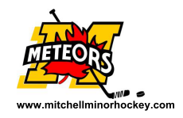
Registration Form
Mitchell Minor Hockey
Pee Wee Tournament - 2019

This tournament is sanctioned by the OMHA / WOAA. The OMHA Approved Tournament Travel Permit must be provided with the registration form. Approved OMHA Roster must be provided ASAP with final roster to be provided at the very latest 1 Hour prior to the first game. Players and bench staff not on the approved roster will be considered ineligible to participate in the tournament.

CENTRE: _____________________________________ OMHA CATEGORY:_____________________

TEAM NAME: _______________________________________________________________________

TEAM COLOURS: HOME ________________________ AWAY ___________________________

Contact information

MANAGER NAME: ____________________________________________________________________

ADDRESS: __________________________________________________________________________

CELL PHONE: __________________________________HOME PHONE: _______________________________

E-MAIL: ____________________________________________ _______________________

Signature

HEAD COACH NAME: _________________________________________________________________

ADDRESS: __________________________________________________________________________

CELL PHONE: __________________________________HOME PHONE: _______________________________

E-MAIL: ____________________________________________ _______________________

Signature

